What is Kubernetes used for?

Kubernetes automates operational tasks of container management and includes build-in commands for deploying applications, rolling out changes to your applications, scaling your applications up and down to fit changing needs, monitoring your applications, and more-making it easier to manage applications.

Is Kubernetes a docker?

While Docker is a container runtime, Kubernetes is a platform for running and managing containers from many container runtimes. Kubernetes supports numerous container runtimes including Docker, containerd, CRI-O, and any implementation of the Kubernetes CRI (Container Runtime Interface).

What is Kubernetes in simple words?

Kubernetes is a portable, extensible, open source platform for managing containerized workloads and services, that facilitates both declarative configuration and automation. It services, support, and tools are widely available.

The name Kubernetes originates from Geek, meaning helmsman or pilot. K8s as an abbreviation results from counting the eight letters between the “K” and the “s”. Google open-sourced the Kubernetes project in 2014. Kubernetes combines over 15 years of Google’s experience running production workloads at scale with best-of-breed ideas and practices from the community.

Going back in time

Let’s take a look at Why Kubernetes is so useful by going back in time.

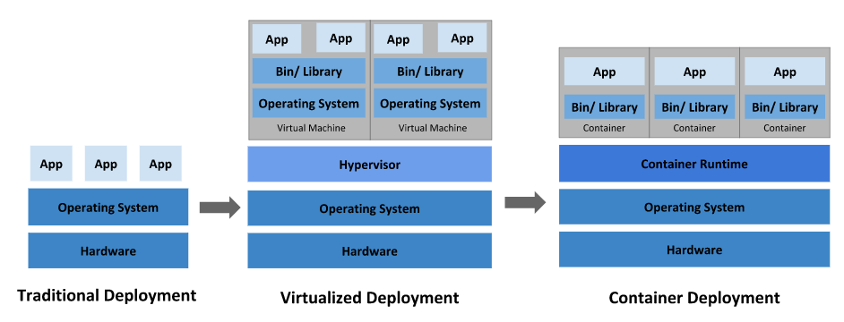

**Traditional deployment era:** Early on, organizations ran applications on physical servers. There was no way to define resource boundaries for applications in a physical server, there can be instances where one application would take up most of the resources, and as a result, the other applications would underperform. A solution for this would be to run each application on a different physical server. But this did not scale as resources were underutilized, and it was expensive for organizations to maintain many physical servers.

**Virtualized deployment era:** As a solution, virtualization was introduced. It allows you to run multiple Virtual Machines (VMS) on a single physical server’s CPU. Virtualization allows applications to be isolated between VMs and provides a level of security as the information of one application cannot be freely accessed by another application.

Virtualization allows better utilization of resources in a physical server and allows better scalability because an application can be added or updated easily, reduce hardware costs, and much more. With virtualization you can present a set of physical resources as a cluster of disposable virtual machines.

Each VM is a full machine running all the components, including it own operating system, on top of the virtualized hardware.

**Container deployment era:** Container are similar to VMs, but they have relaxed isolation properties to share the Operating System (OS) among the applications. Therefore, containers are considered lightweight. Similar to a VM, a container has its own filesystem, share of CPU, memory, process space, and more. As they are decoupled from the underlying infrastructure, they are portable across clouds and OS distributions.